# Exercise: HTML and CSS: Forms and Media Queries

## Media Queries in Typography

Upgrade your typograpgy.css file from previous exercises. Create the following page for different screen sizes:

**Desktop:**

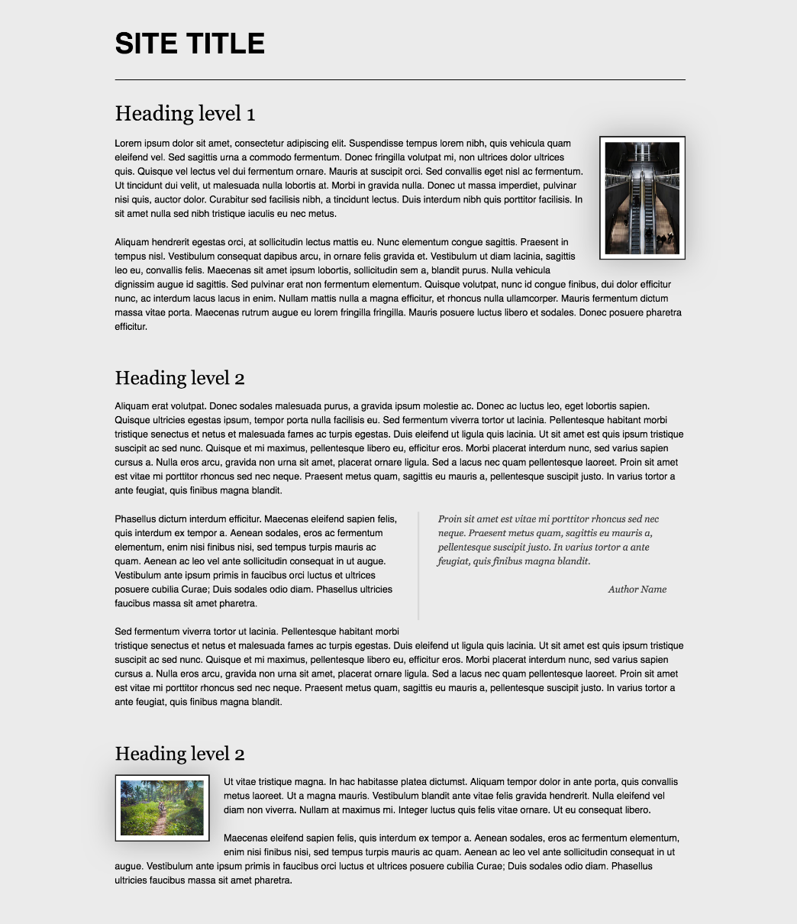

**Laptop:**

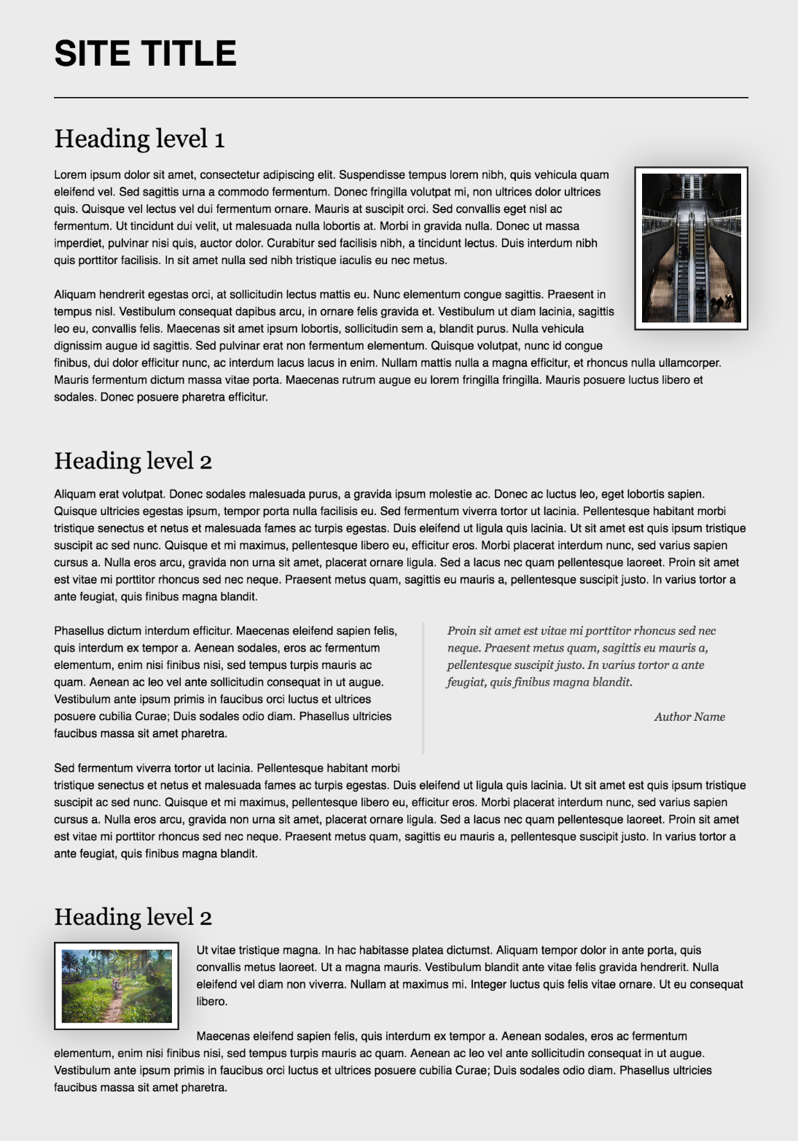

**Tablet:**

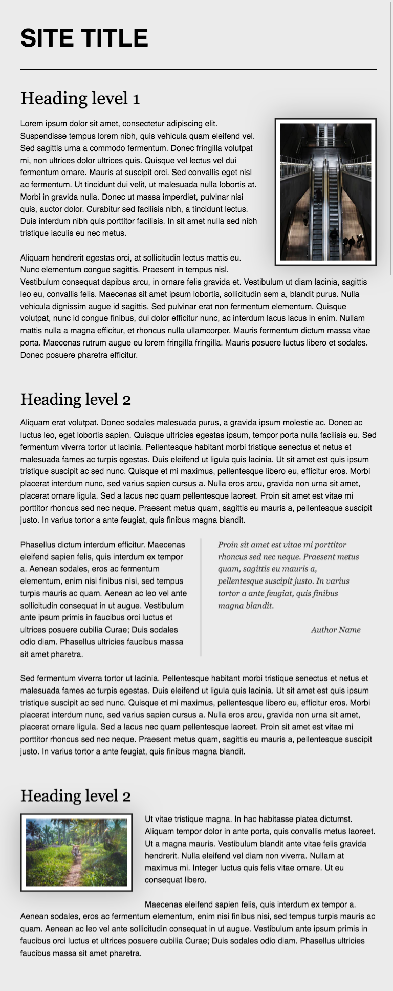

**Phone:**

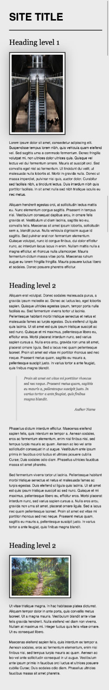

### Requirements

* Change the document **title** to "**Media Queries in Typography"**
* Make the font size for **phones** 12px
* Make the font size for screens **larger** than 500 14px
* Make the font size for screens **larger** than 600 16px
* Make the font size for screens **larger** than 800 18px
* Make the font size for screens **larger** than 1300 21px
* Make the font size for screens **larger** than 1800 23px

## Responsive Forms

Create a web page like the following:

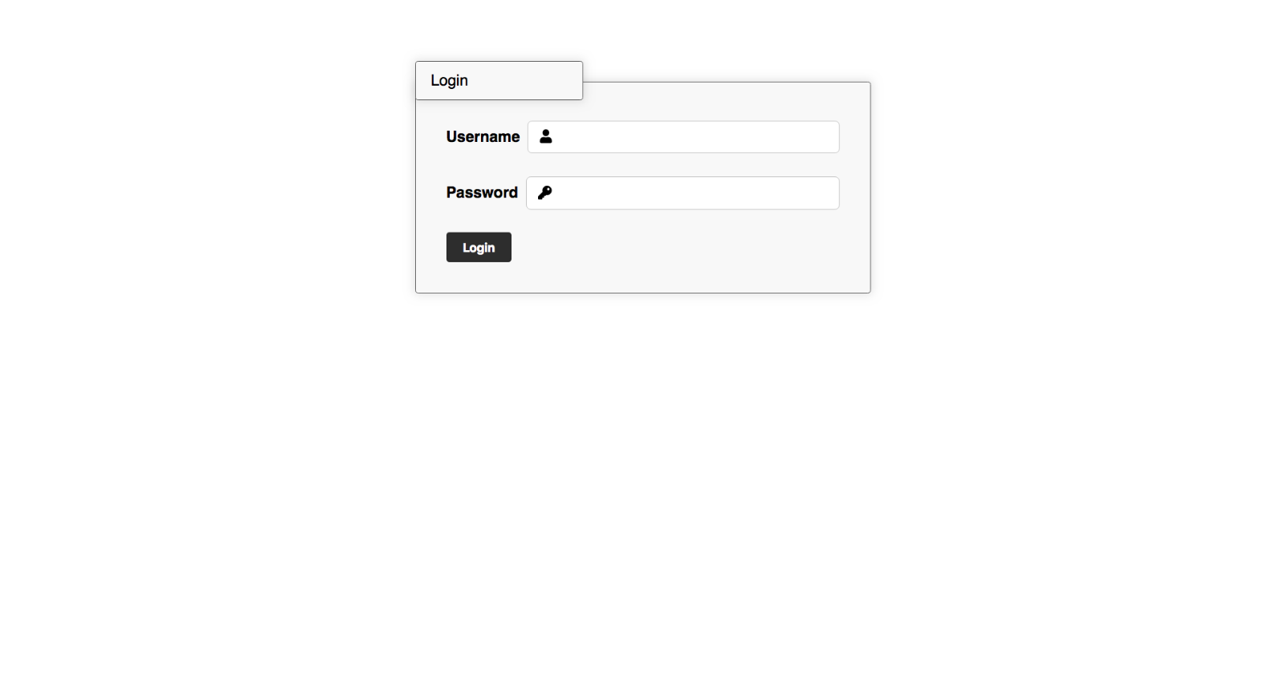

* Look at the provided screenshots in **resources** **folder** for different screen size’s view

### Requirements

* Change the document title to "**Responsive Forms**"
* Create a simple login form using **semantic** html
  + Add icons to the input fields using **FontAwesome**
  + Add focus state that changes the **input** and the **icon**
  + User **form** and two **p** tags

## Responsive Media Boxes

Create a web page like the following:

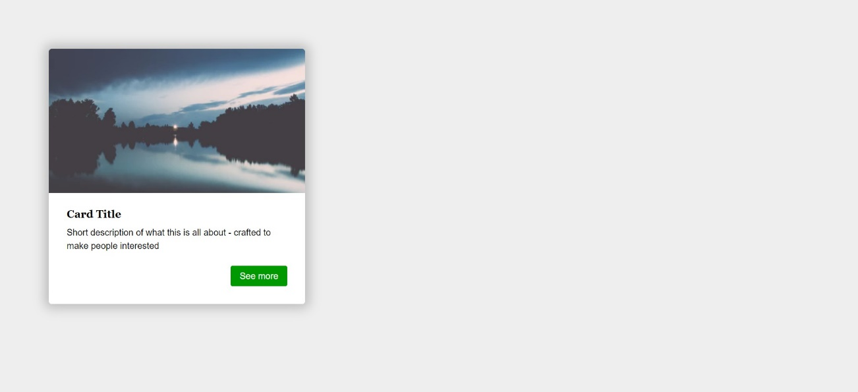

### Requirements

* Change the document title to "**Responsive Media Boxes**"
* Create a section with two div elements
* You can access the image [here](https://images.unsplash.com/photo-1538230942844-e89414a0692d?ixlib=rb-0.3.5&ixid=eyJhcHBfaWQiOjEyMDd9&s=34dcc54db235ce71b59c1d5ada02bdc4&auto=format&fit=crop&w=400&q=80)
* Use rgb(238, 238, 238) for body background
* Use rgb(255, 255, 255) for card background
* Use rgb(0, 153, 0) for card button background
* Use font Georgia, serif with size 1em/1.2 for the headings
* Use font Helvetica, sans-serif for the document

## Landing Page

Create a web page like the following:

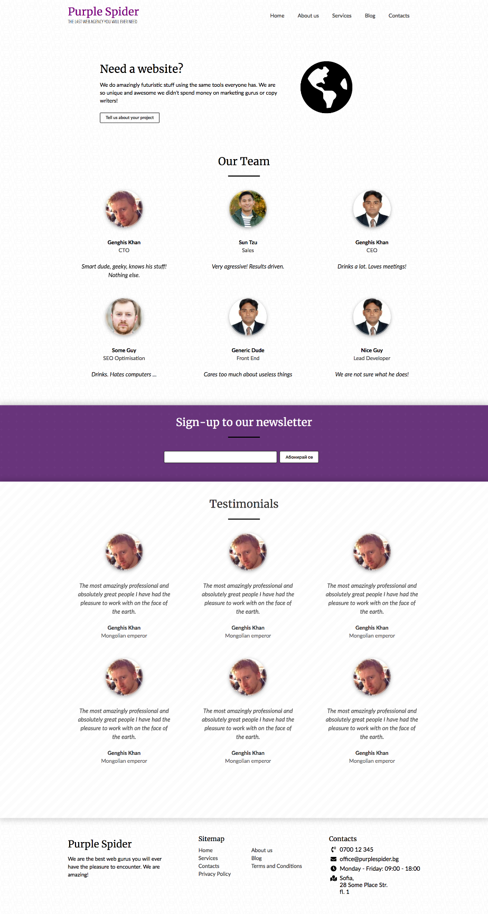

* Look at the provided screenshots in **resources** **folder** for different screen size’s view

### Requirements

* Change the document title to "**Landing Page**"
* Get the latest reset.css
* Get the latest typography.css
* Get the latest buttons.css
* Get the latest forms.css
* Create a section with a title Need a website?
* Create a section with a title Our Team
* Create a section with a title Sign-up to our Newsletter
* Create a section with a title Testimonials
* Create a footer
* Make the page **responsive** per the screenshots attached

## Responsive Tables

Create a web page like the following:

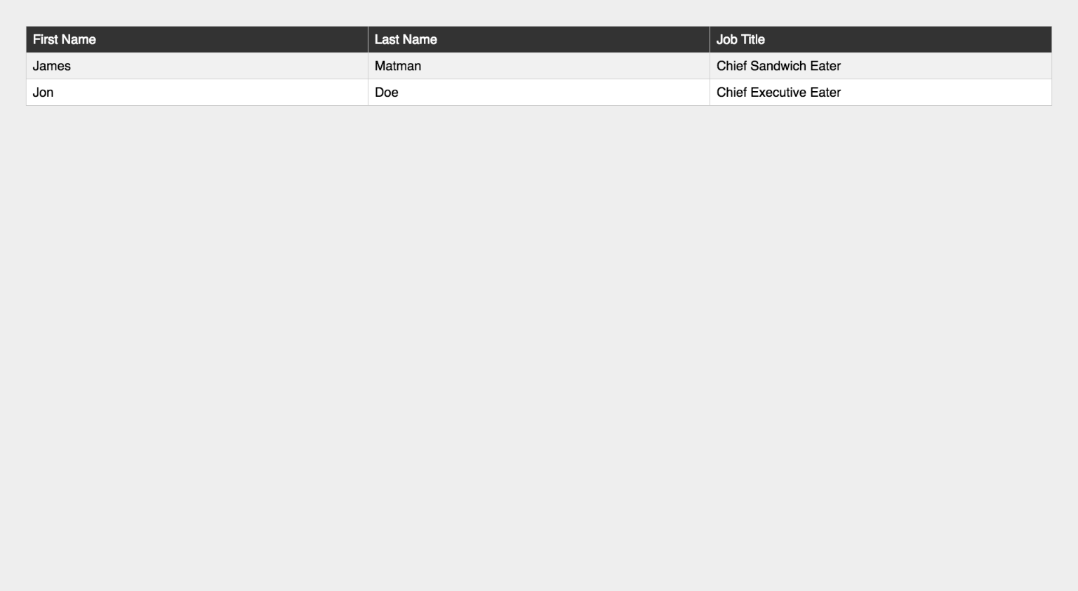

* Look at the provided screenshots in **resources** **folder** for different screen sizes view

### Requirements

* Change the document title to "**Responsive Tables**"
* Create a table with 3 columns: First Name, Last Name, Job Title
* Get the latest reset.css
* Get the latest typography.css
* Make the table **responsive**

## Responsive Vertical Timeline

Create a web page like the following:

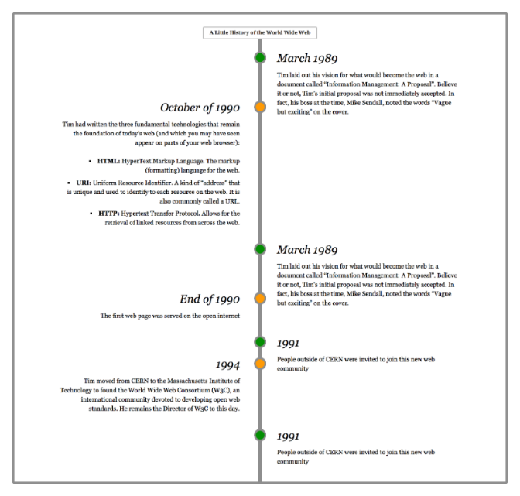

* Look at the provided screenshots in **resources** **folder** for different screen sizes view

### Requirements

* Change the document title to "**Responsive Vertical Timeline**"
* Create a section with class timeline
  + The section must have
    - Border width - 0.3rem
    - Border color - rgb(153, 153, 153)
    - Border style - solid
* Create seven articles (article) in the section
  + Divide **article content** into header and section
  + The header has h3 heading and the section has a paragraph with text inside
  + Style h3 font to italic
* Add media queries for the list to look good on **mobile** and **desktop**

## Tag Cardio: Form

Create a Web Page, using **form tag**.

Create a file named form.html. Set the html title to be the same as the task name.

## Tag Cardio: Input

Create a Web Page like the following:

Картина, която съдържа текст, линия, Правоъгълник, бял

Описанието е генерирано автоматично

Create a file named input.html. Set the html title to be the same as the task name.

Use **input** with **type="text"** to solve the problem.

Outside on **input** tag need to be put **form** tag.

**Hint: Use <br> tag for new line!**

## Tag Cardio: Textarea

Create a Web Page like the following:

Картина, която съдържа текст, екранна снимка, Шрифт, номер

Описанието е генерирано автоматично

Create a file named textarea.html. Use the texts from the filesite-texts.txt. Set the html title to be the same as the task name.

Use **textarea** to solve the problem.

Outside on **textarea** tag need to be put **form** tag.

## Tag Cardio: Label

Create a Web Page like the following:

Картина, която съдържа текст, екранна снимка, Шрифт, линия

Описанието е генерирано автоматично

Create a file named label.html. Use the texts from the filesite-texts.txt. Set the html title to be the same as the task name.

Use **label** to solve the problem.

Outside on **label** tag need to be put **form** tag.

## Tag Cardio: Button

Create a Web Page like the following:

Картина, която съдържа текст, Шрифт, Графика, лого

Описанието е генерирано автоматично

Create a file named button.html. Use the texts from the filesite-texts.txt. Set the html title to be the same as the task name.

Use **button** to solve the problem.

## Tag Cardio: Fieldset Legend

Create a Web Page like the following:

Картина, която съдържа текст, екранна снимка, линия, Правоъгълник

Описанието е генерирано автоматично

Create a file named fieldset-legend.html. Use the texts from the filesite-texts.txt. Set the html title to be the same as the task name.

Use **fieldset** to solve the problem.

Outside on **fieldset** tag need to be put **form** tag.

## Tag Cardio: Select Option

Create a Web Page like the following:



**↓**

Картина, която съдържа текст, Шрифт, екранна снимка, номер

Описанието е генерирано автоматично

Create a file named select-option.html. Use the texts from the filesite-texts.txt. Set the html title to be the same as the task name.

Use **select and option** to solve the problem.

## Tag Cardio: Datalist

Use skeleton, which is in resources to solve the next problem:

Картина, която съдържа Правоъгълник, екранна снимка, линия, бял

Описанието е генерирано автоматично

**↓**

Картина, която съдържа текст, екранна снимка, дизайн

Описанието е генерирано автоматично

Create a file named datalist.html. Use the texts from the filesite-texts.txt. Set the html title to be the same as the task name.

Use **datalist** to solve the problem.

Outside on **datalist** tag need to be put **form** tag.